Part and Assembly Template Download and Opening Instructions
- Download Template Files on Machine Shop homepage.
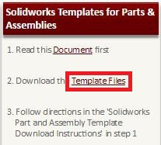

- Open file location
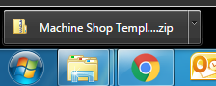

- Copy the following:
C:\ProgramData\SolidWorks\SolidWorks 2012

- Extract all Files
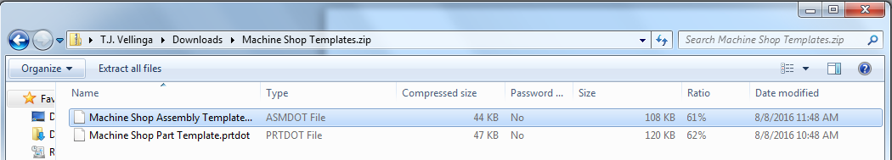

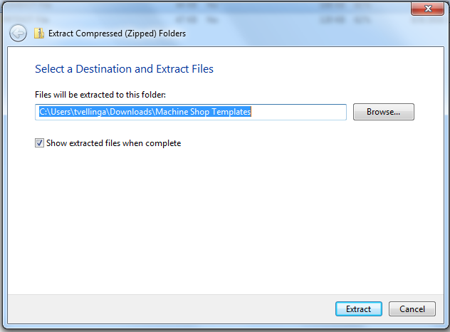
- Paste “C:\ProgramData\SolidWorks\SolidWorks 2012” into the text box and push Extract

- Open Solidworks

- Create new document
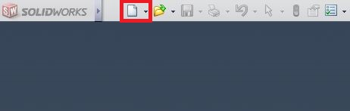
- Go to advanced
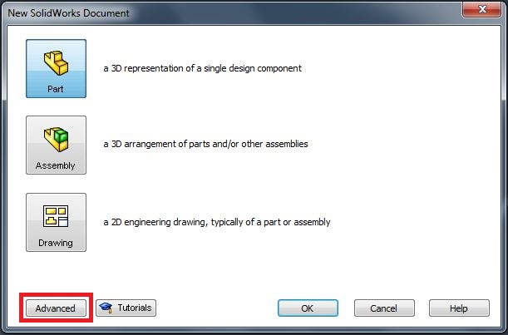

- Choose either “Machine Shop Assembly Template.asmdot” or “Machine Shop Part Template.prtdot” depending if you want a new part or assembly and hit ok
